Pokhara University

Level: Bachelor | Semester – Spring | Year : 2007
Programme: BE |  | Full Marks: 100
Course: Engineering Mathematics IV |  | Time : 3hrs.

Candidates are required to give their answers in their own words as far as practicable.
The figures in the margin indicate full marks.

Attempt all the questions.

 | - Define harmonic function. Verify that 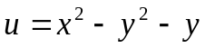 is harmonic and find conjugate harmonic of . Also find the corresponding analytic function.  - State Cauchy integral theorem. Evaluate the integral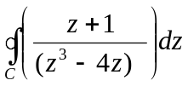, where C is the circle 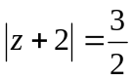 in anticlockwise direction. | 8  7
 | - State Laurent’s theorem. Find the Laurent’s series for  f(z) = 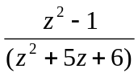 in the region 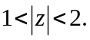  OR  Solve one-dimensional wave equation completely.  - Define Z-transform of a function. Find Z-transform of 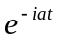 and hence deduce the values of Z(cos at) and Z(sin at) | 8  7
 | - State the first shifting theorem for Z transform and hence find:  - Z(cos at)  - Z(sin at)  - Find 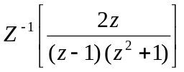. | 8  7
 | - Find the solution of one dimensional heat equation 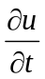 = c² 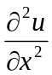, having zero temperature in end points and initial temperature f(x).  - Derive one dimensional wave equation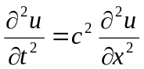 .  OR  Find the solution of one dimensional wave equation with initial deflection sin3x + sinx and initial velocity is zero. | 7  8
 | - What is Helmholtz’s equation on F(x,y) and solve it subject to F(0, y) = 0 = F(a, y) = F(x, 0) = F(x, b).  OR  Find the vibrations of a rectangular membrane of sides a = 4 ft and b = 2 ft. if the tension is 12lb/ft, the density is 2.5 slugs/ft², the initial velocity is 0 and the initial displacement is f(x, y) = 0.1(4x- x²) (2y- y²) ft.  - Maximize the total output z = 3x₁ + x₂ subject to input constrains x₁ + x₂ ≤ 12x₁ + 3x₂ ≤ 5, x₁ ≥ 0, x₂ ≥ 0. | 8  7
 | - What is a Fourier Integral? Using Fourier integral, show that 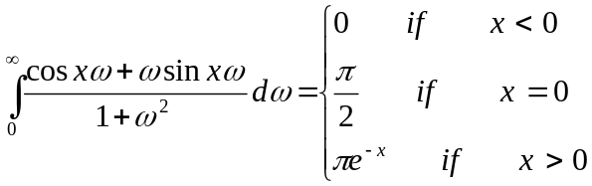  - Find the Fourier cosine transform of the function f(x) = e^{-ax} (a>0). | 8  7
 | Attempt all the questions.  - Solve U_{xy} + U_{x} = 0  - Show that 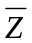 is not analytic.  - Write down the equation of an ellipsoid and then sketch.  - Find the Fourier sine transform of e^{-5x}.  - Evaluate the integral 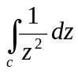, where C is a unit circle. | 5×2

